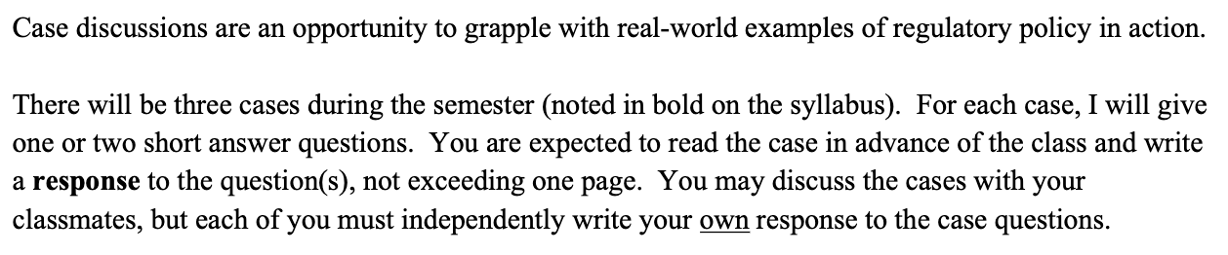
DO NOT USE ANOTHER/OUTSIDE SOURCE. THE DOCUMENT FILE 8 (THE READING: STANDING UP FOR STEEL) THAT I SENT IS THE ONLY SOURCE THAT YOU CAN USE.

